**Youtube Video Link** : https://www.youtube.com/watch?v=dam0GPOAvVI&t=372s

**Github link** for code: https://github.com/AnnaMohan/Flask-Web-App-Tutorial

If we place this **__init__.py** file it makes the folder as a python package

Essentially we can import this folder , and whatever is inside in __init__.py will run automatically.

Models.py (for database models)

Views.py( views or urls for all the frontend functioning)

Flask is lightweight framework but not used in production.

**Installations**

pip install flask

pip install flask-login

pip install flask-sqlalchemy

**__init__.py**

app = Flask(__name__)

__name__ just represents the name of the file /name of the file that was ran.

app.config[‘SECRET_KEY’] = ‘TYPE SOME RANDOM STRING HERE’ THIS LINE🡪Encrypt cookies and session data

---------------------------------------

**main.py**

if __name__ = ‘__main__’:

app.run(debug=True)

only when we run this file not import this file or we going to execute the app.run(debug=True) line

for some reason if you import main.py from another file and if you didn’t have this(if __name__ = ‘__main__’:) line it would run the webserver and you don’t want that to happen.

You want to the server only when you actually run this file directly.

App.run line is going to run our flask application it is going to a webserver and, it say debug=  
true if we say debug=true it means whenever we make any change to the python code the server will automatically rerun.

Views.py

Where the use can navigate to except login page all details are mentioned here.

Blueprint 🡪it means it has a bunch of roots inside it and a bunch of urls defined it.

We are going to define that this file is an blueprint of our appln.

There is no need to write all views in a single file we can split the views in multiple files and we can make everything organized.

Views = Blueprint(‘views’, __name__) -🡪 using the line as it is **recommended**.

No need to keep it as same as name of the file but it will be easy if we do that way.

 from flask import Blueprint

 views = Blueprint('views', __name__)

this is the way to create a blueprint for views

do the same in auth.py but replace views with auth then it will be auth blueprint

both of these are having different views and different URL_Story define inside of them.

So lets define our first view,

Whenever you got to / location home function will run.

Whenever you go to url mention by @(decorator) , to which function this @ is there that function will run on the run mentioned.

For eg:

Now we need **register** these blueprints in __init__.py

All of the urls that are stored in this blueprint file how I would access them?

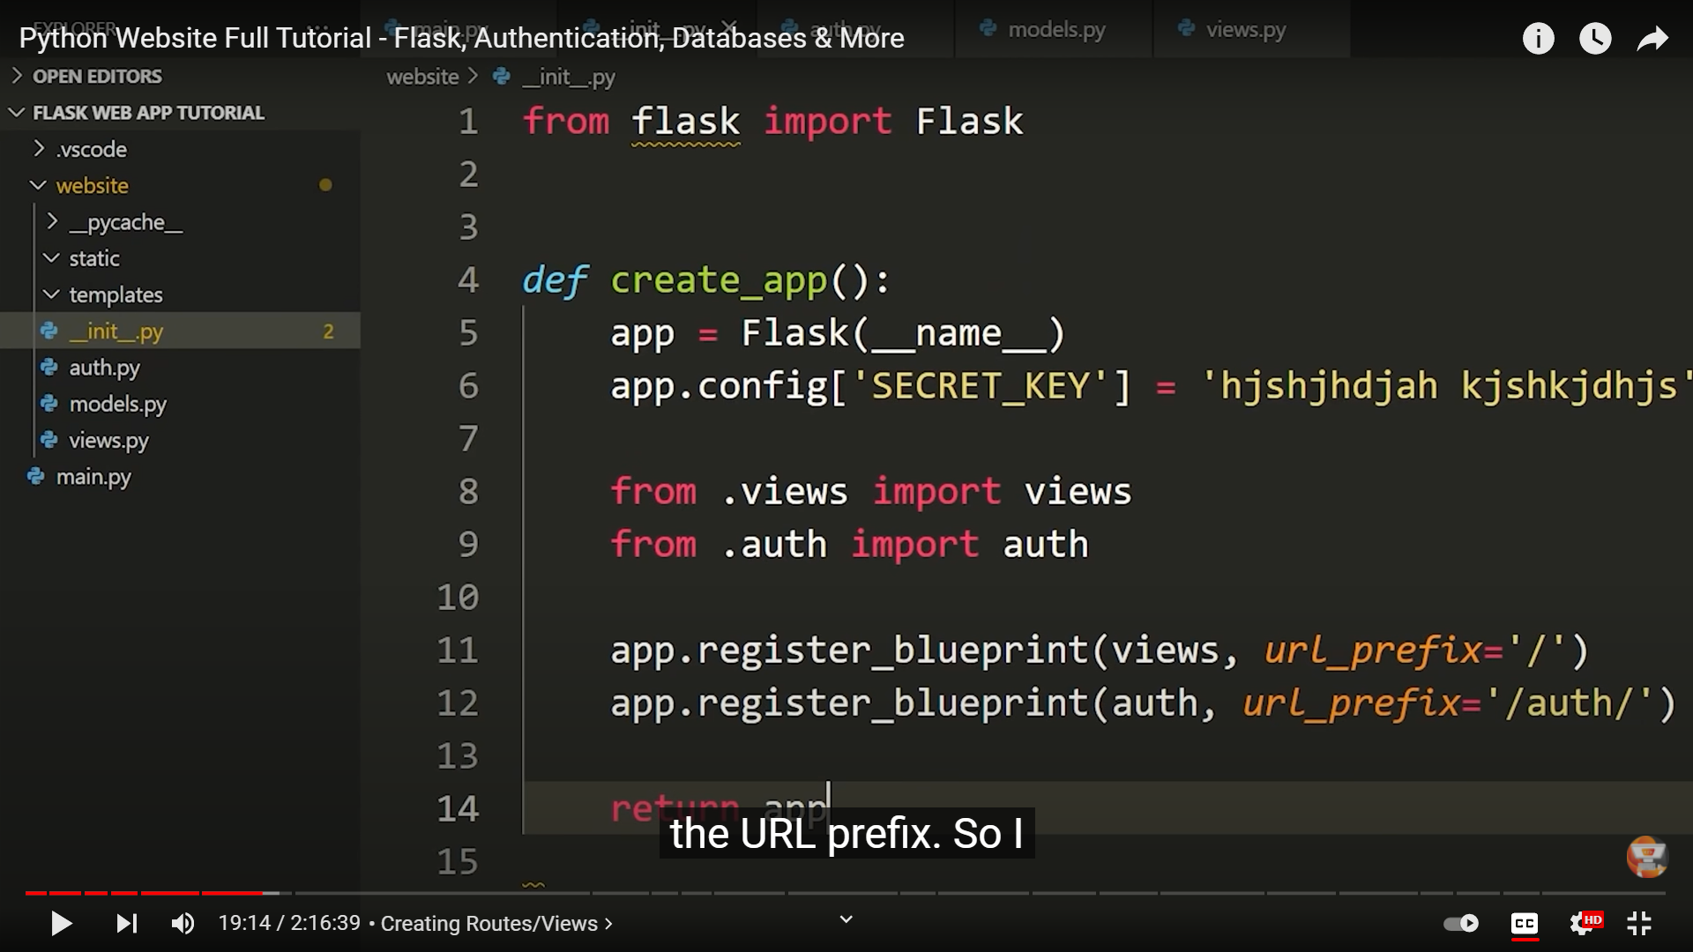

Let if make the auth blueprint url_prefix as ‘/auth/’

Then if we you want to access any view in this blueprint you need to use /auth before the route of the view you want to go.

So keep ‘/’ for auth blueprint as well.

Jinja template allows us to write python inside the html documents

That’s why we call html files inside templates folders as templates because we are using jinja templating language.

Whenever you create templates you create file called **base.html** in simple we can it is the **theme** of your appln.

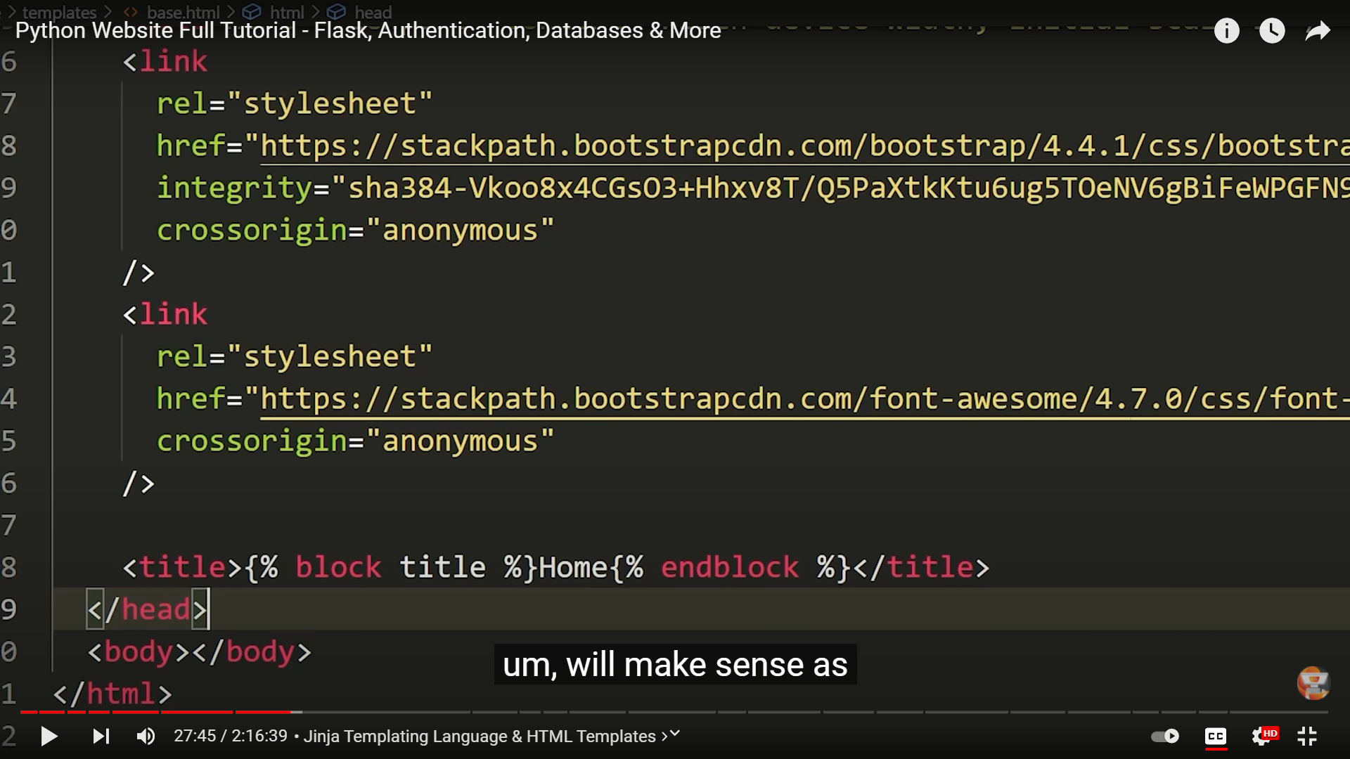

What does it mean by block title

It means im defining a block in this base template that can be overridden in a child template.

If home is there Home in this block in this base file if in child template if we keek something that will override this home and shows whatever you wrote in the child template.

The links in the above picture are for bootstrap cdn.

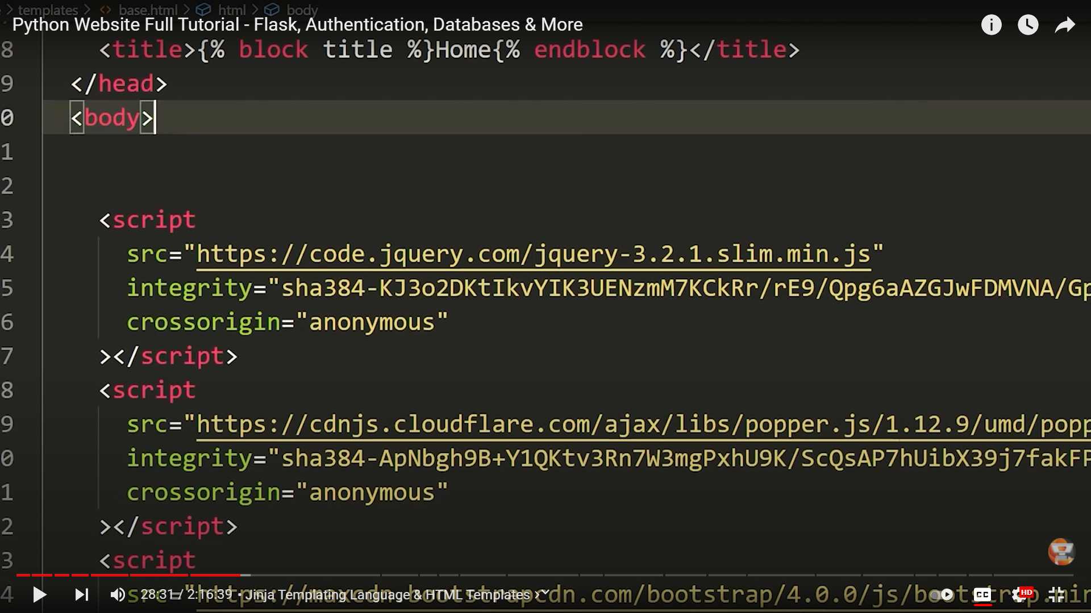

These scripts are Javascript related to bootstrap which we are using from cdn.

Images, javascript files, css whatever the static content is present all those are kept in **static** folder.

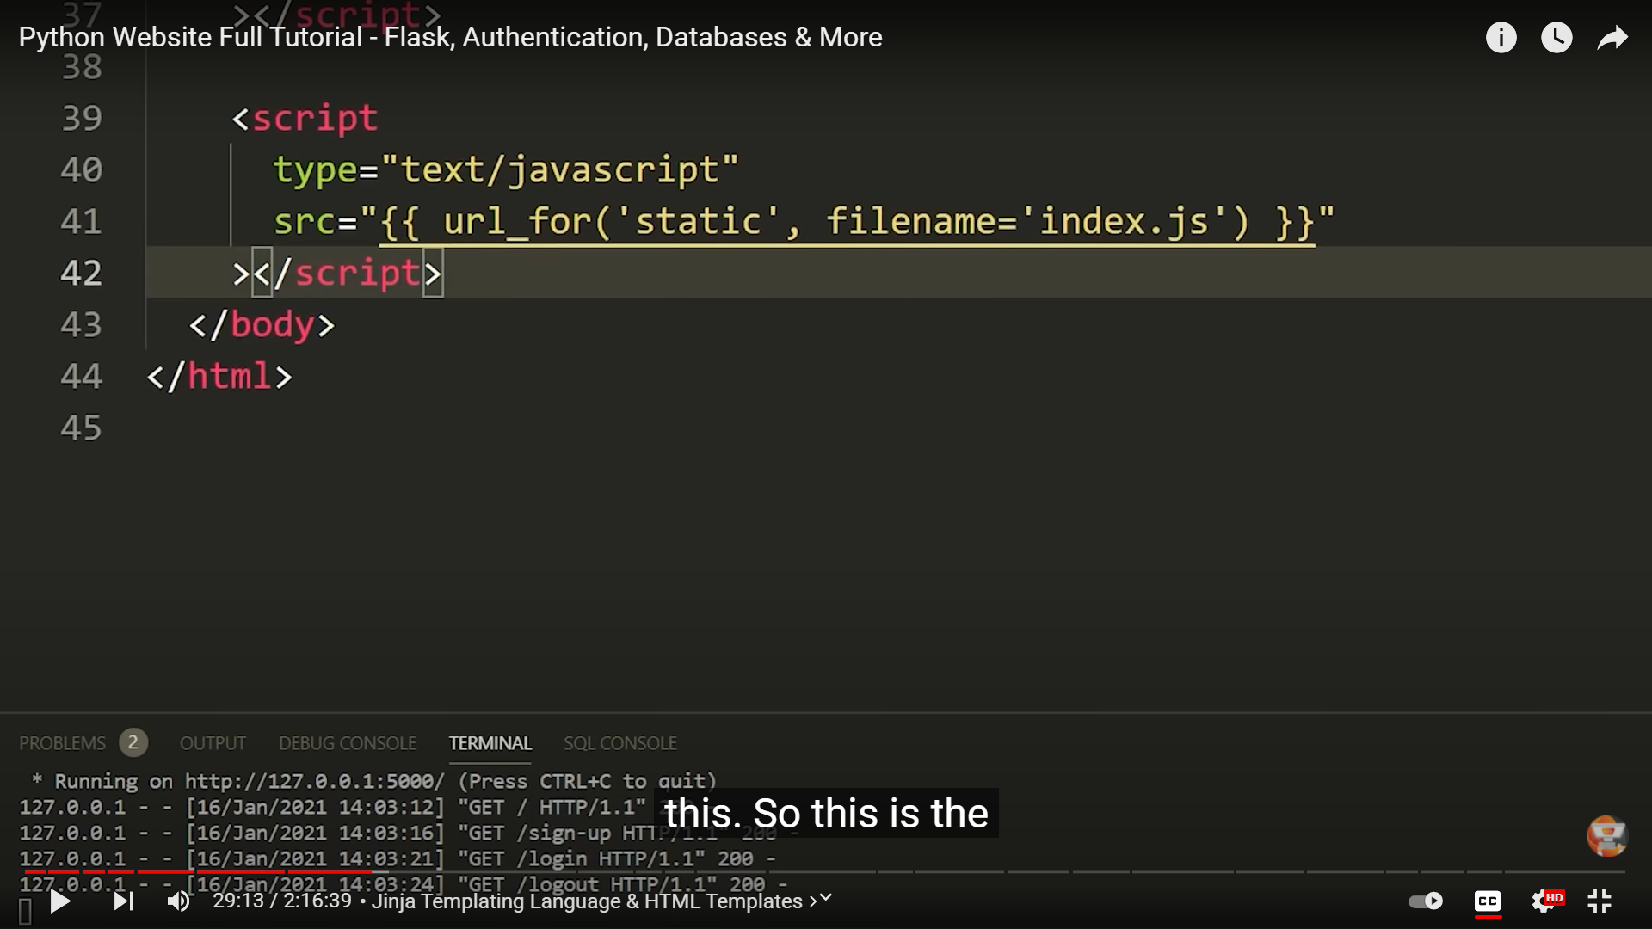

You can load the static content from static folder into html by using the script in above image

So basically the img have the script to load the index.js file from the static folder

Again here we are using jinja template “{{ url_for(folder_name, filename=’file_name’) }}”

This to say the folder name and file name which you want to use here.

url_for is a python function, it loads the url for our static folder.

{{ }} 🡪 this we are going to write a python expression it can be a variable,function etc that will be evaluated.

There are also some rules to write the type of python expression here, but basically we use these brackets for python expression.

**#** represents the **id** of something.

32:30 in video discussion of navbar

**Prettier** is an extension in vscode which formats the code automatically.

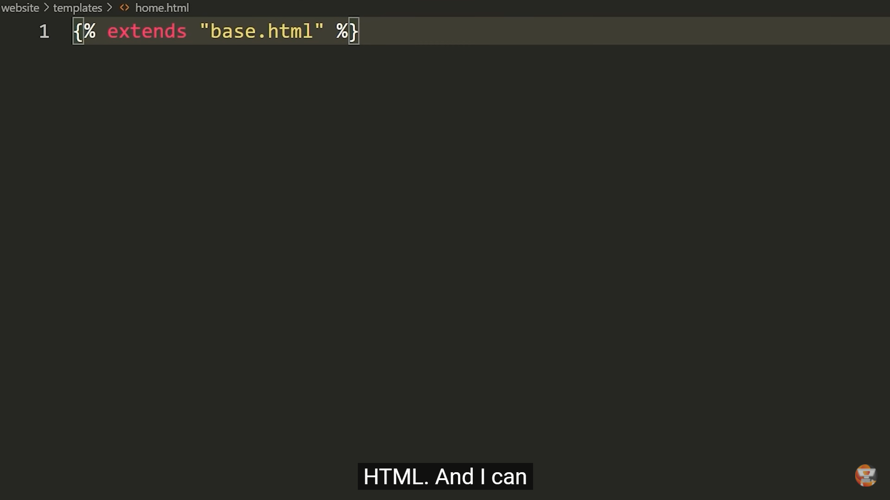

This template here will be the same as base.html and can override any blocks that are written in base.html

**The code is available in github link provided at the starting of the document**

Till now we made the template, if you want to see its result you need to render it.

Whenever you want to render something you need to import render_template from flask

By using jinja you can **pass variables,values** to templates.

We can pass multiple variables as well.

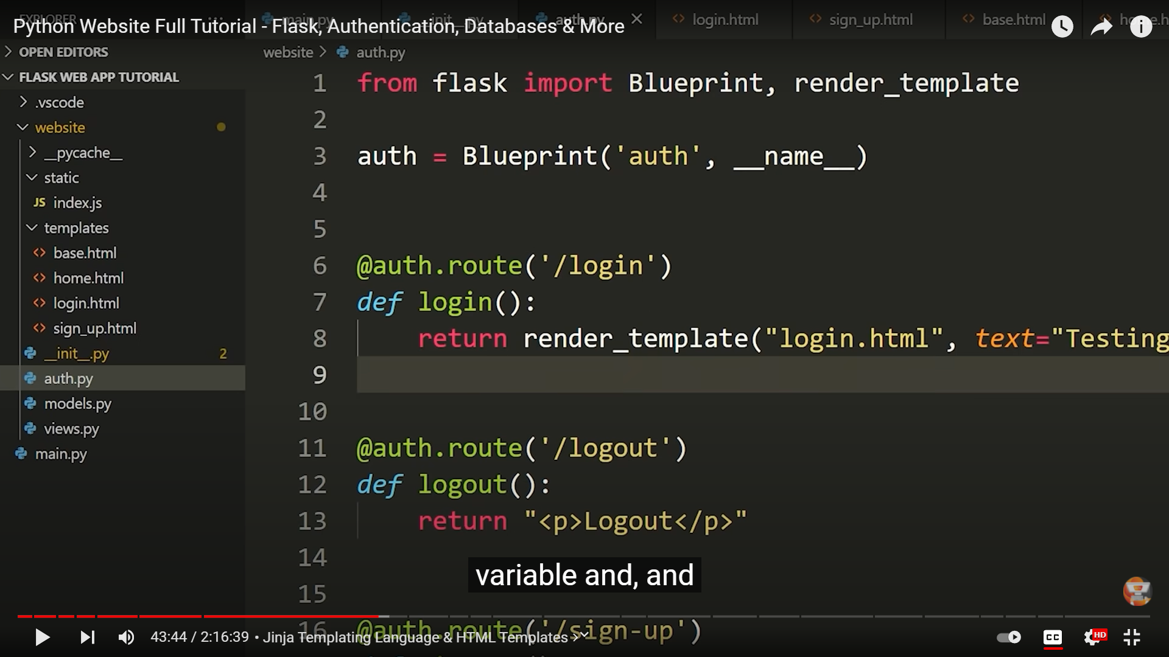

Here a variable named text is defined and we can store something in this variable, the value given to this variable is can be accessed inside login.html in jinja as

{{ text }}

When you render this page it displays the value you have stored in this variable

<!-- You can create blocks using jinja template where you feel while extending

this file you need some custom content in other files -->

<!- here atfirst we are using the base.html template -->

<!-- Im using the block which i created in base.html to display the title of the page -->

<!-- Basically, block is the area where we can override the contents of template,

    which you are extending in this current file i.e base.html -->

<!-- Here another block is also created before ending the block you can add your content

that need to be displayed specific to this file irrespective of base.html -->

{% extends "base.html" %} {% block title %} Home{% endblock %}{% block content %}

<h1> content </h1>

<h1> This is Home Page </h1>

{% endblock %}

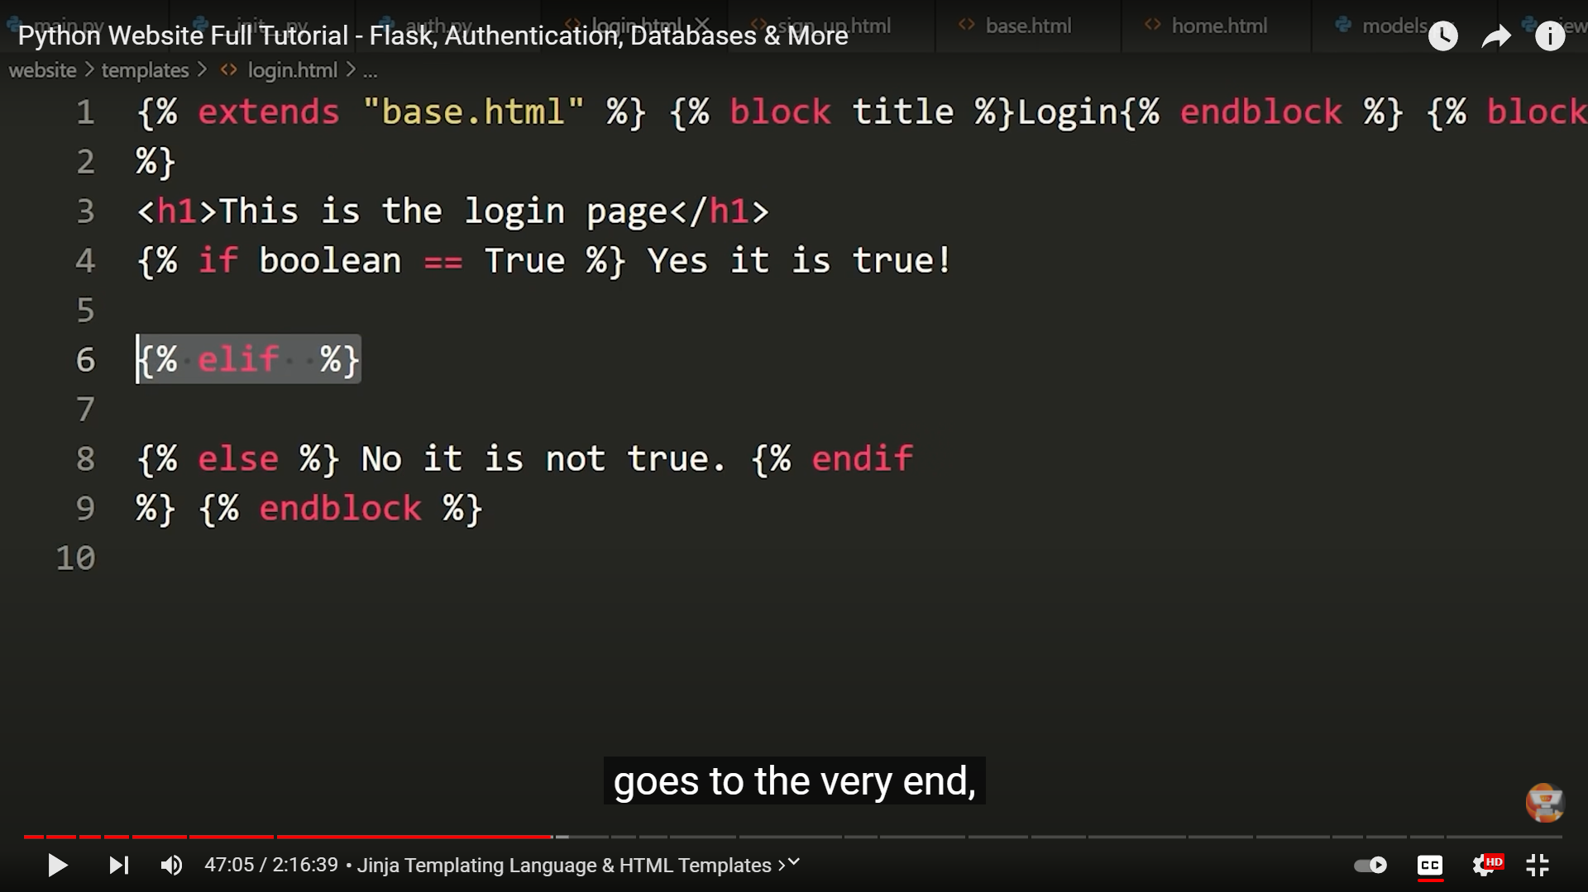

You can write if else and elif also in jinja like above way.

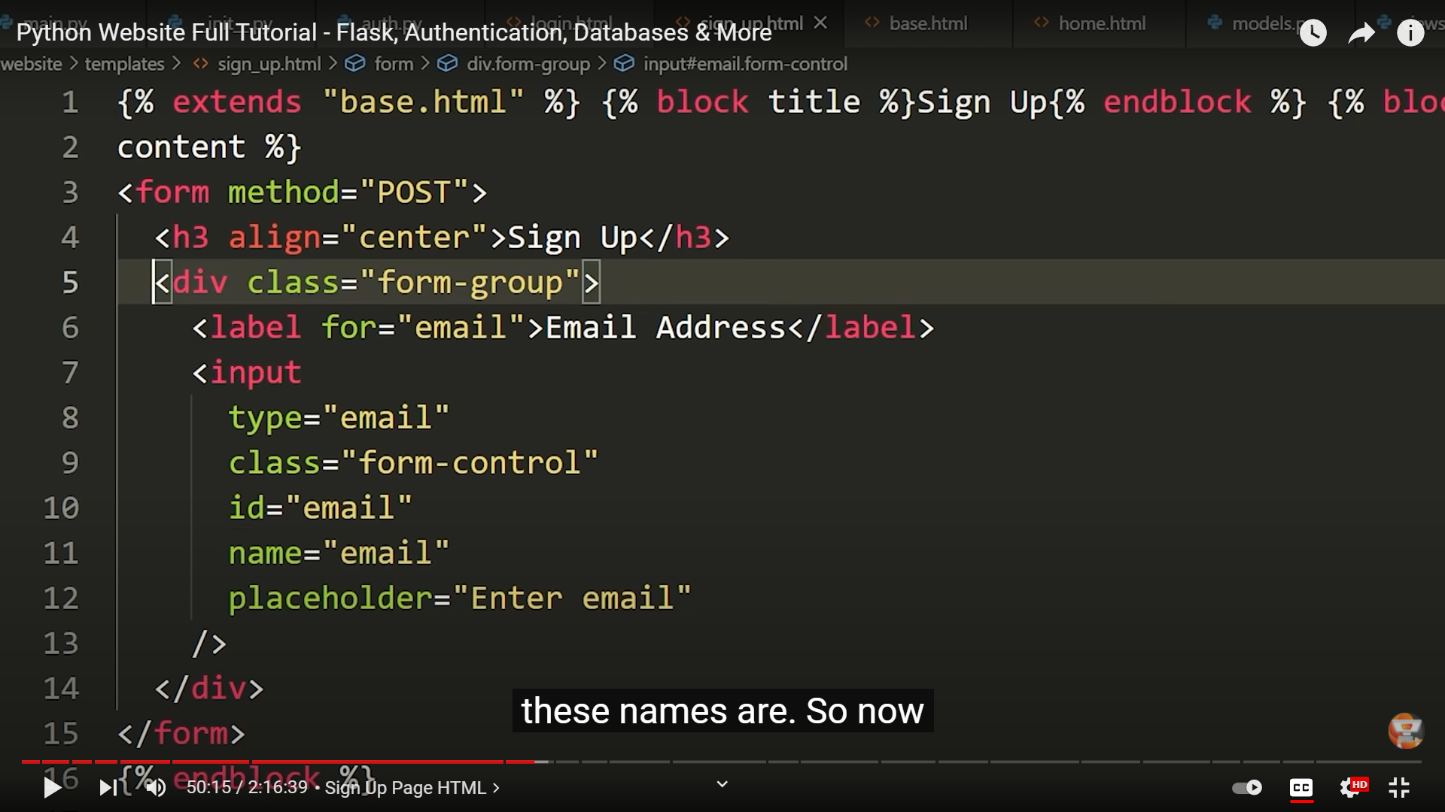

These names are used when you submit the form while sending the data to backend then these name is used to identify the email and whatever you are using it for.

For our purposes name should be same as id, note this is for purpose of this app.

Routes need to know which type of requests they are getting such as post, get, put etc.

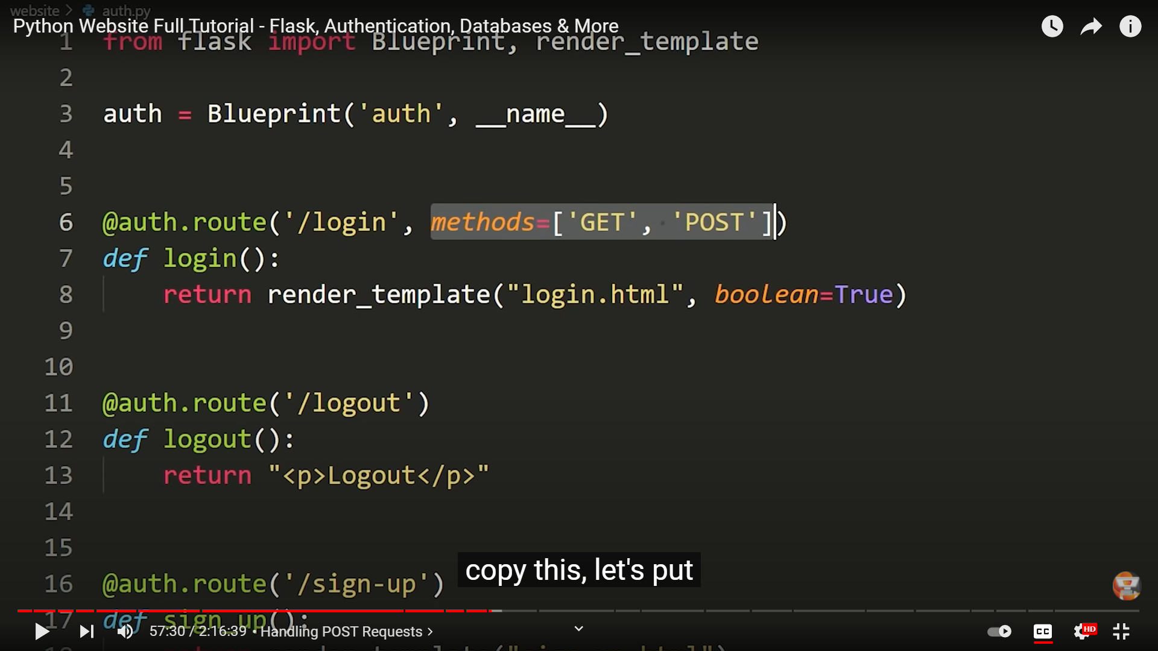

If you want a route to accept some type of request then you need to mention them in a methods list in route argument it self.

It means this route now accept GET and POST requests bydefault only GET is included.

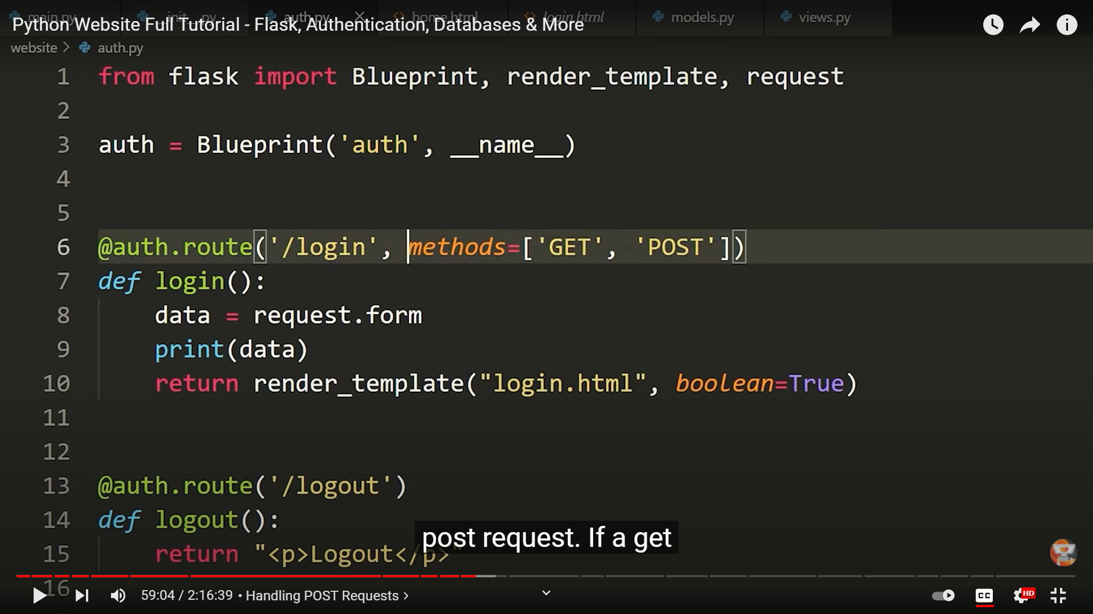

So, here in login method we used data variable which gets the data from the form with the help of request and prints it . this will only work with post we send a get **request** it doesn’t do anything.

Request will have access to all the data in the login form.

See below image what happens with get nothing will be displayed and also post with no info passing it just shows the empty quotes in the dictionary keys.

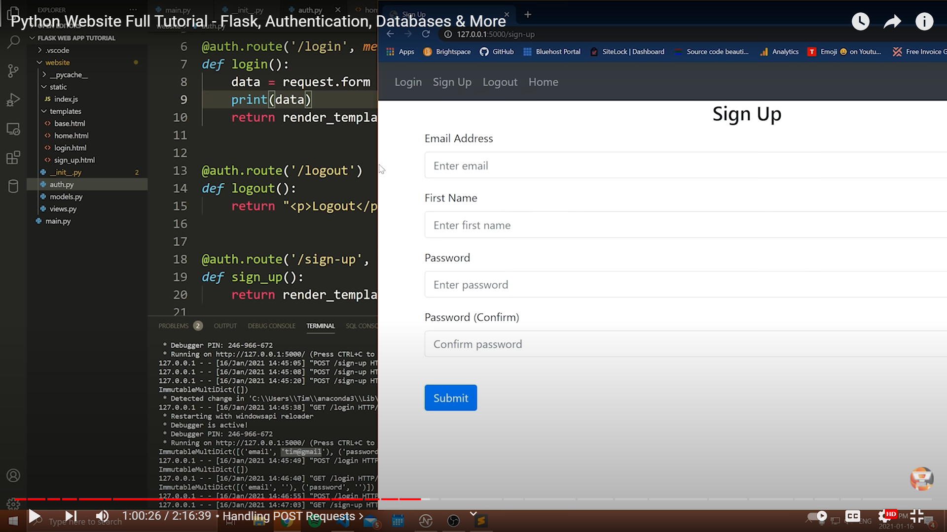

So if you want to display alerts while validated the user info in the form use **flash** functionality provided by flask

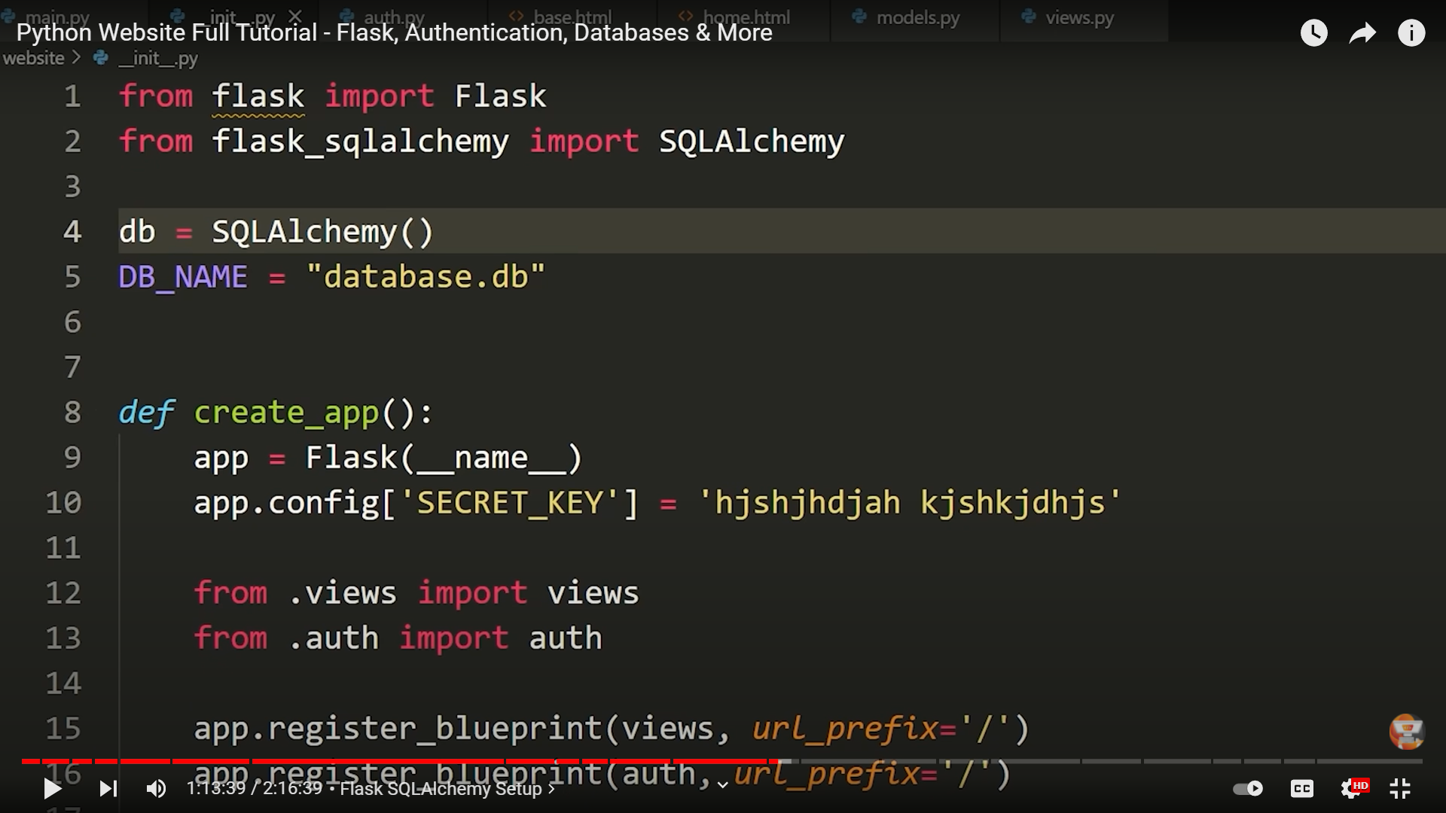

Import SQLALCHEMY from flask

And intialise the db, db is the obj which is used for everything

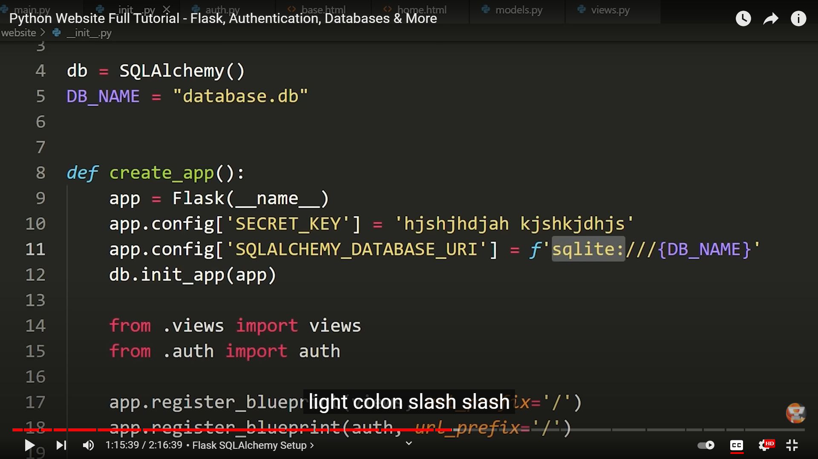

Here we are saying db that this is the app we are going to use with database

Sqlite:///{DB_NAME} is the location where the database resides.

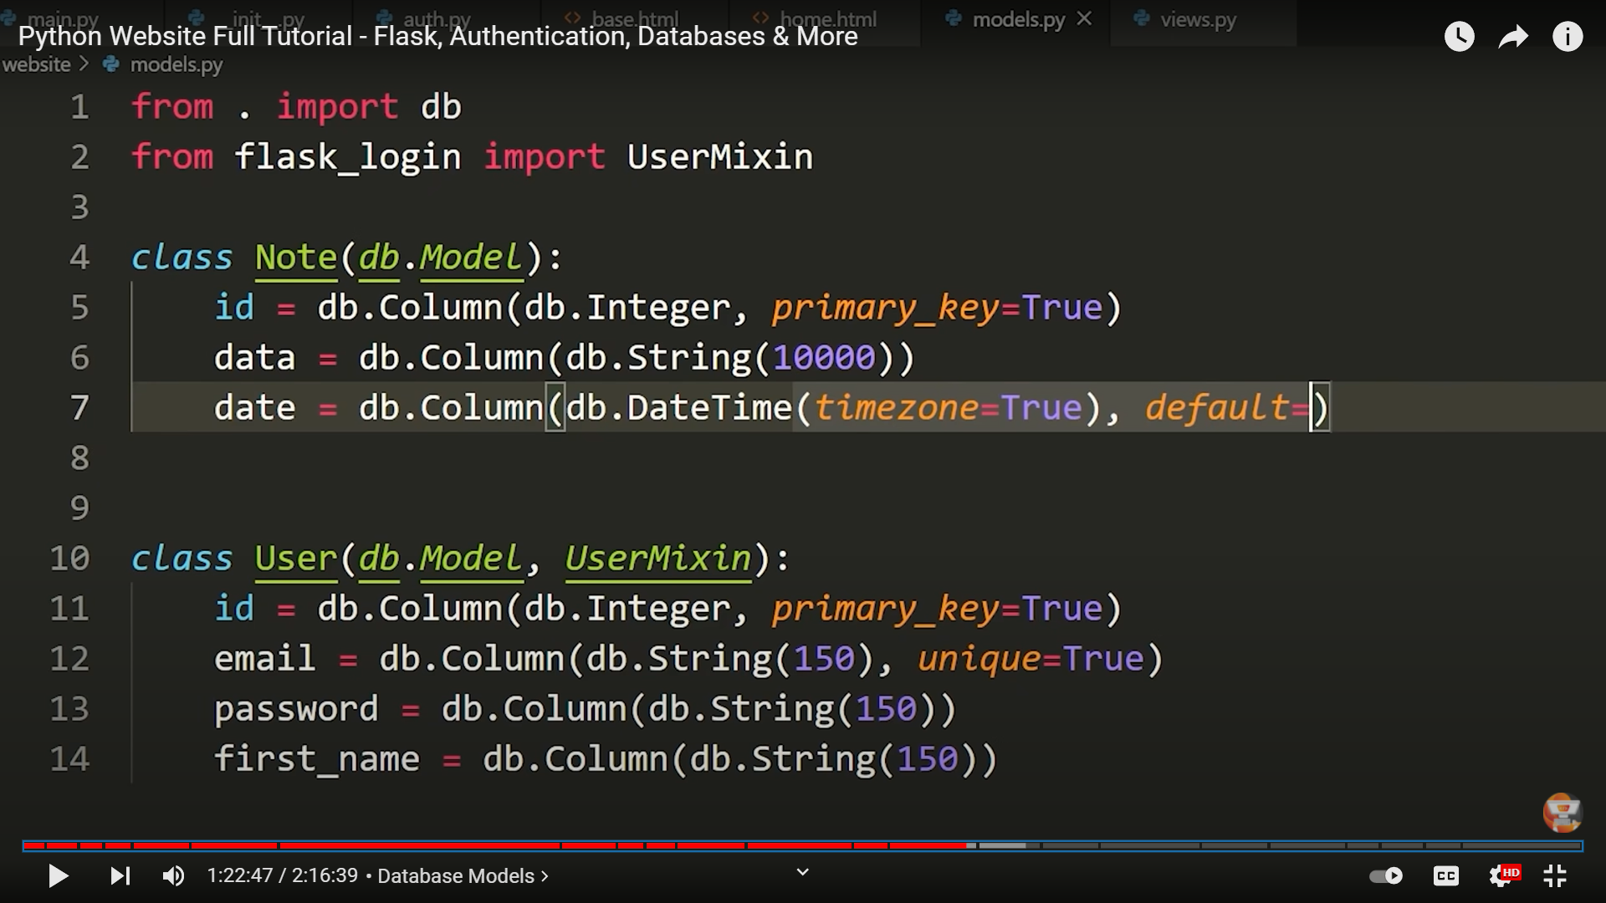

Creating database models

**Database model** is just like a **model** or **blueprint** for an **object** that's going to be store in the database.

creating User class creating the schema means ,we created the User model

unique = true --> this means no user can have the

same email

here we are **inheriting** the Model and UserMixin classes in User class

In every database to uniquely identify a object we need to have a **primary key.**when you add new id that is automatically incremented these databases are smart enough.

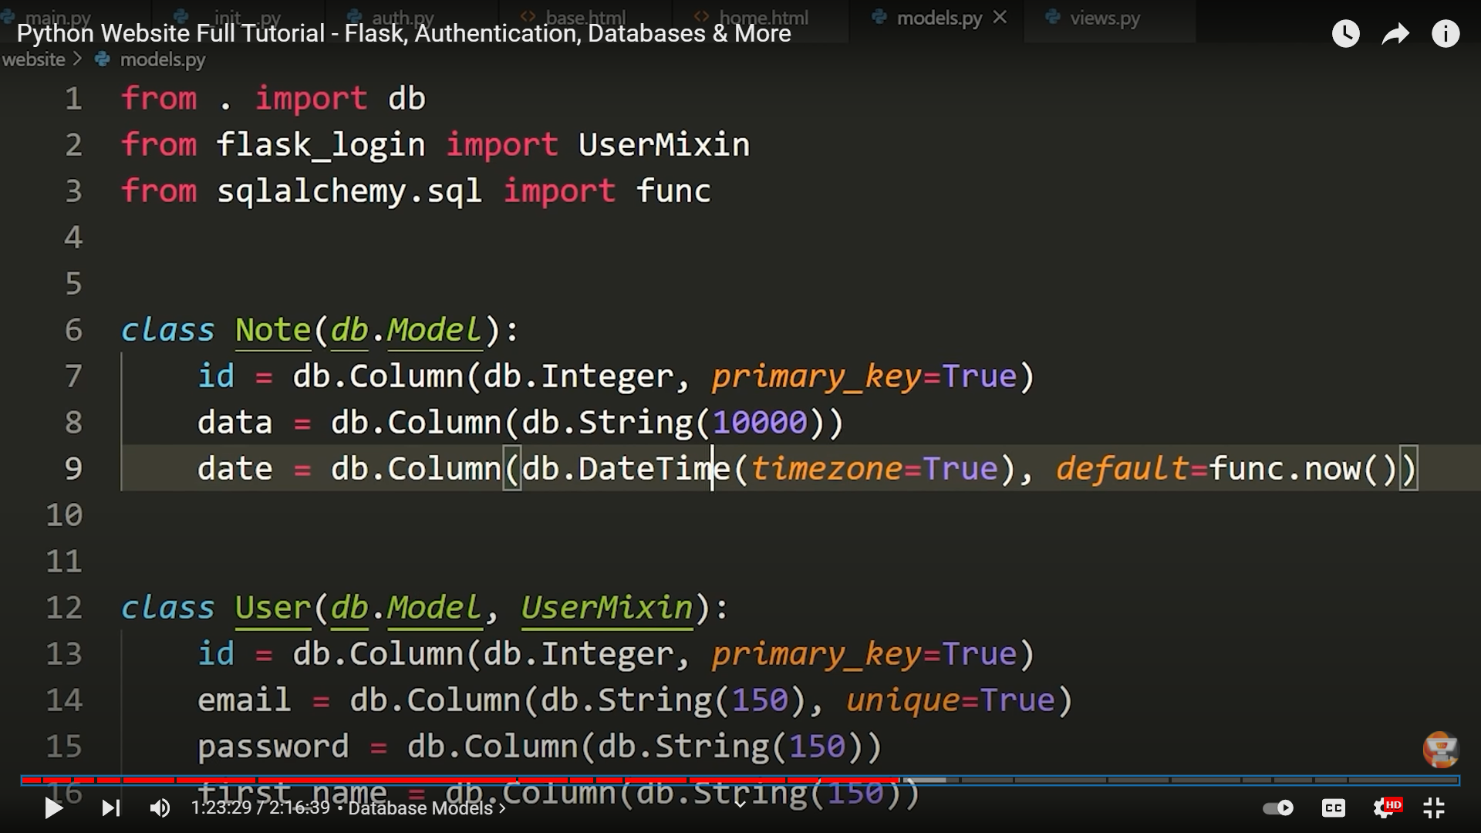

Func will automatically add date,time for us when we add a new note.

A **FOREIGN KEY** is **a field (or collection of fields) in one table, that refers to the PRIMARY KEY in another table**. The table with the foreign key is called the child table, and the table with the primary key is called the referenced or parent table.

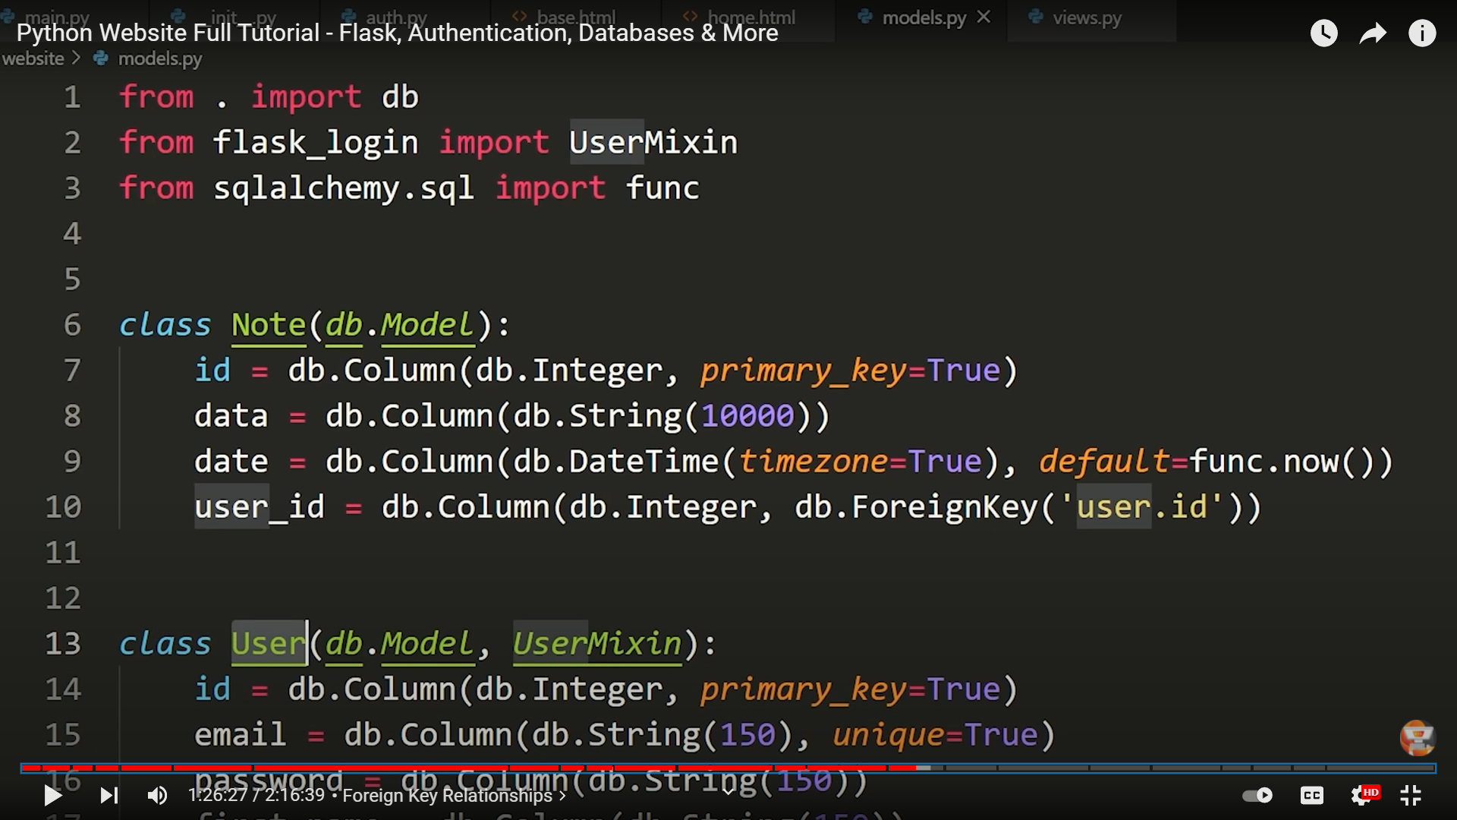

In sql the User class is represented as user in line10 only in foreign key case else capital case is only used as normal scenario.

Here user.id means we are getting the primary key of the user from the user database

If incase the primary is like email,mobile no, then I would have said user.email/mobileno.

Here we are using **one to many** relationship of database

Becoz one user can create many notes

And everytime we create a notes add this into User notes relationship that note id.

This relationship field is a list it will store all of the different Notes.

Notes relationship line in User’s table in below image

We will be able to access all of the notes that a user owns are created from notes field by denoting this db.realtionship

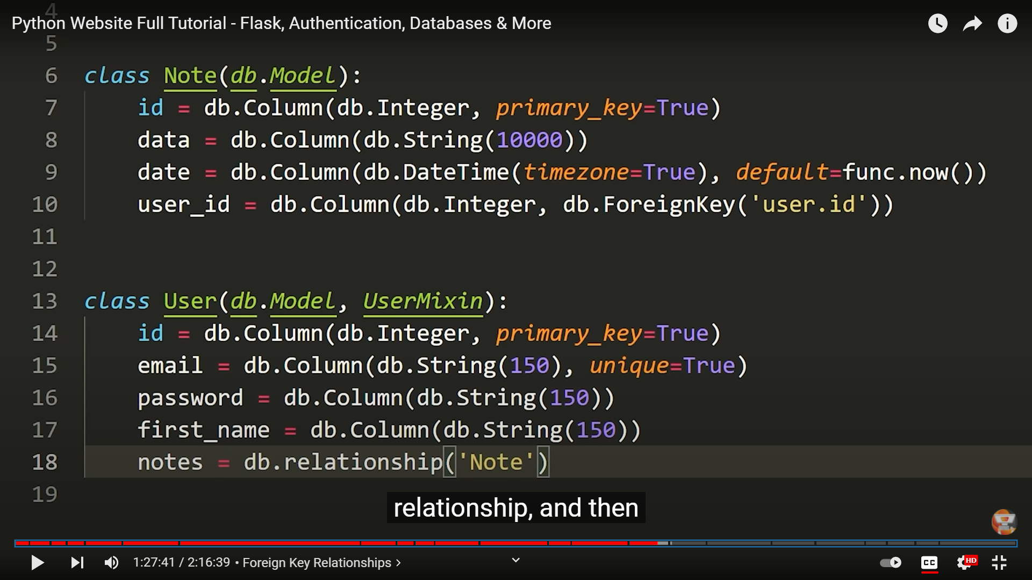

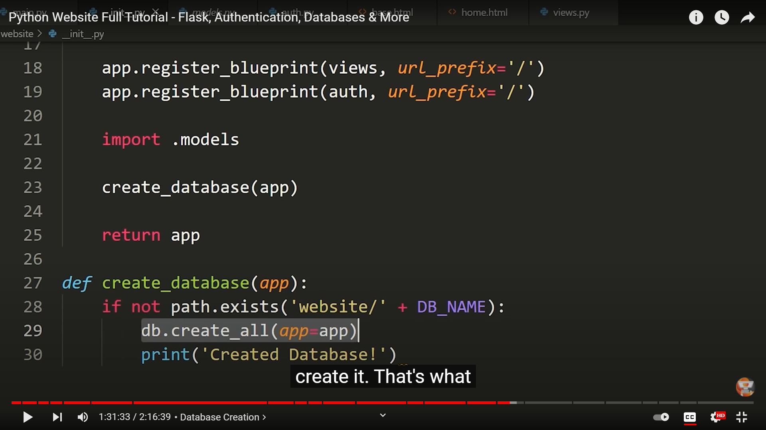

We use the path module and check whether database exists if not, then it creates else it won’t.

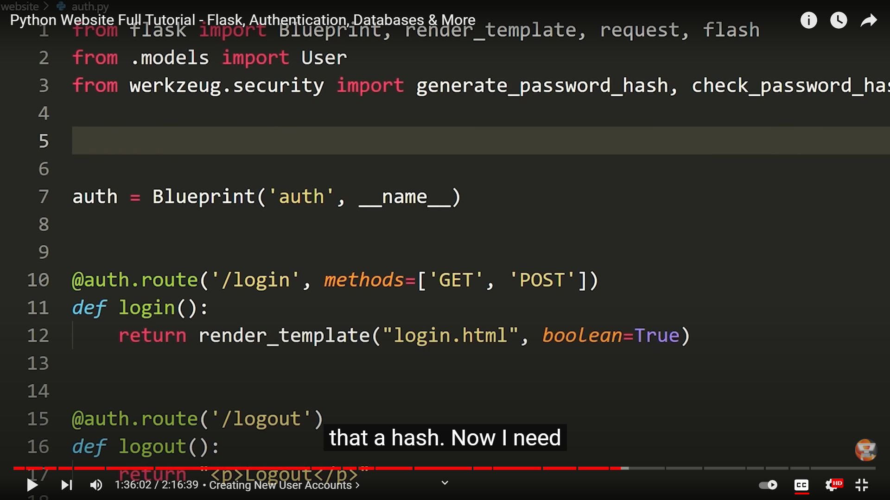

Need to use werkzeug.security import generate_password_hash , check_password_hash to secure the password it means not to store the password in the plain text.

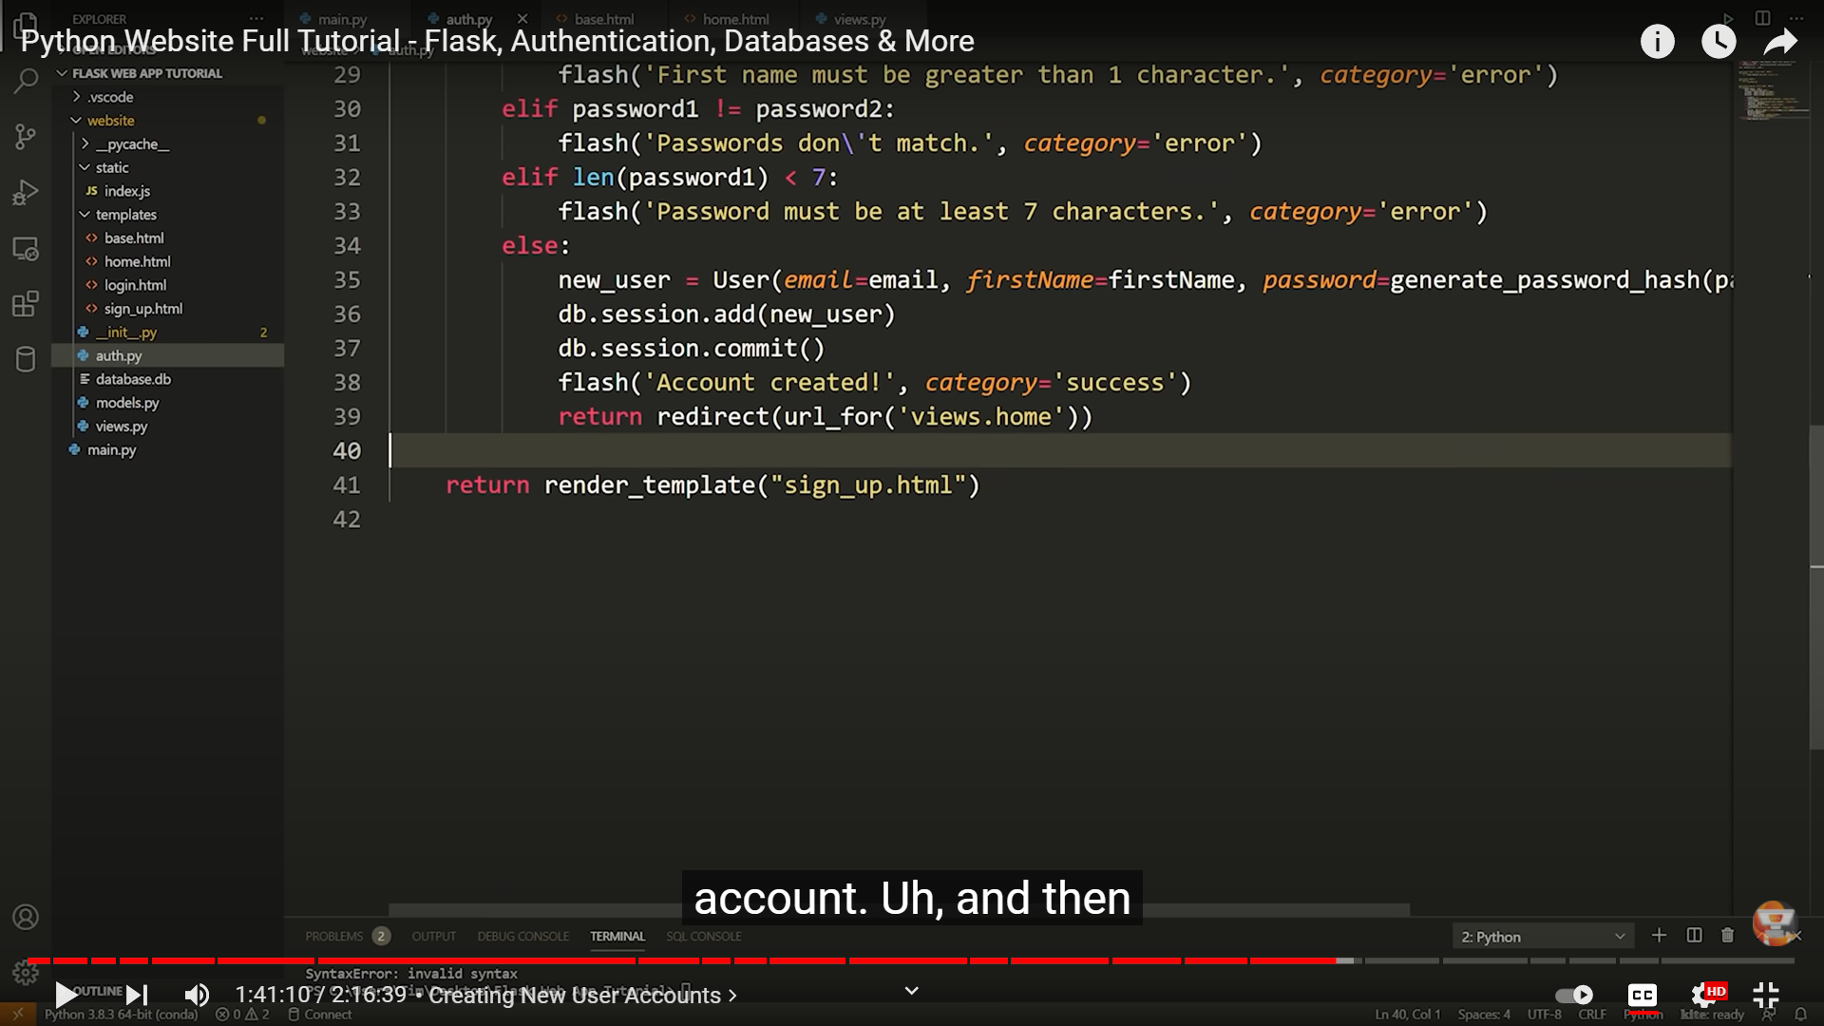

Db.session.add(new_user) 🡪 adding the new user to the database User.

Db.session.commit() 🡪 to update the database with new details

Passwords are stored after hashing the you cant get back the password from hash

If you want to authenticate the users you just need to hash the password they enter and need to check the old password hash with this new one if those matches it means the password entered is correct.

New_user 🡪 we are passing the user details into this new_user to store it in the database

It is getting these details from the models.py

After a user is successfully created we need to route the user to the homepage so that’s why we are redirecting the user to homepage

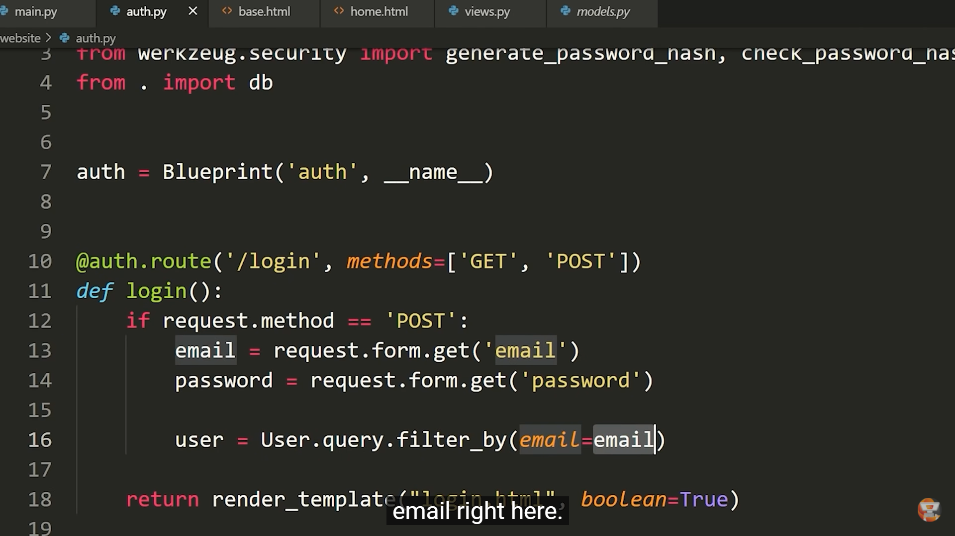

Filter all the users having the email field

If the user exists compare the password with the password in the database if successfully matched redirect user to the homepage.

If you observe **without logging in homepage is accessible** so we need to change this now,and also login and signup should not be displayed even after logged in.

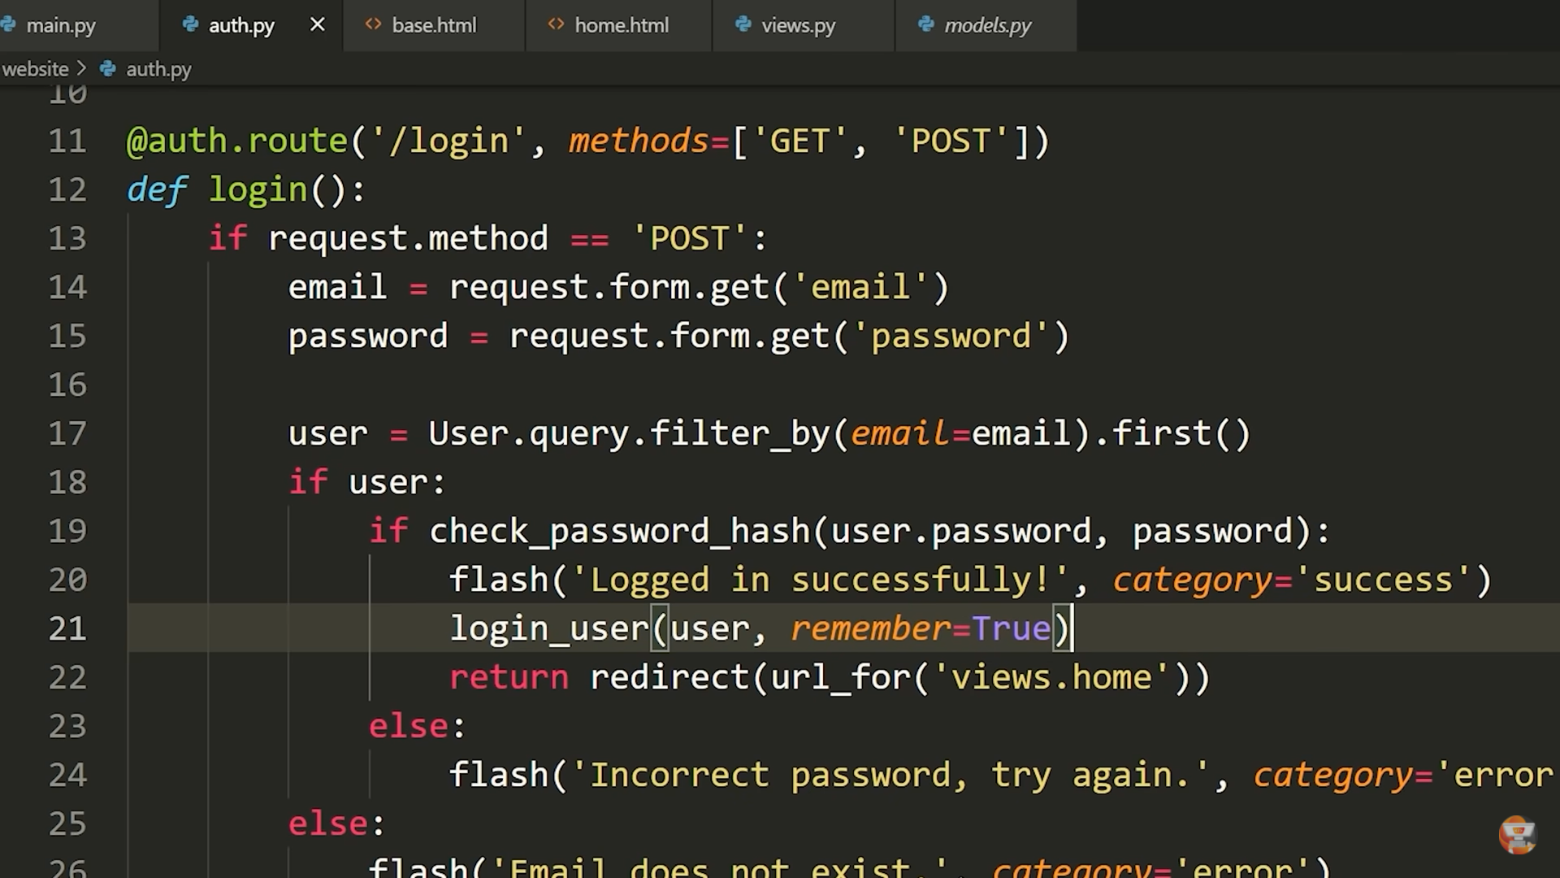

Here login_user(user,remember = True)

This **remembers the current user** until and unless the user clear the cookies from browser or the flask server restarts.

So there is no need login every single time you go in to the website.

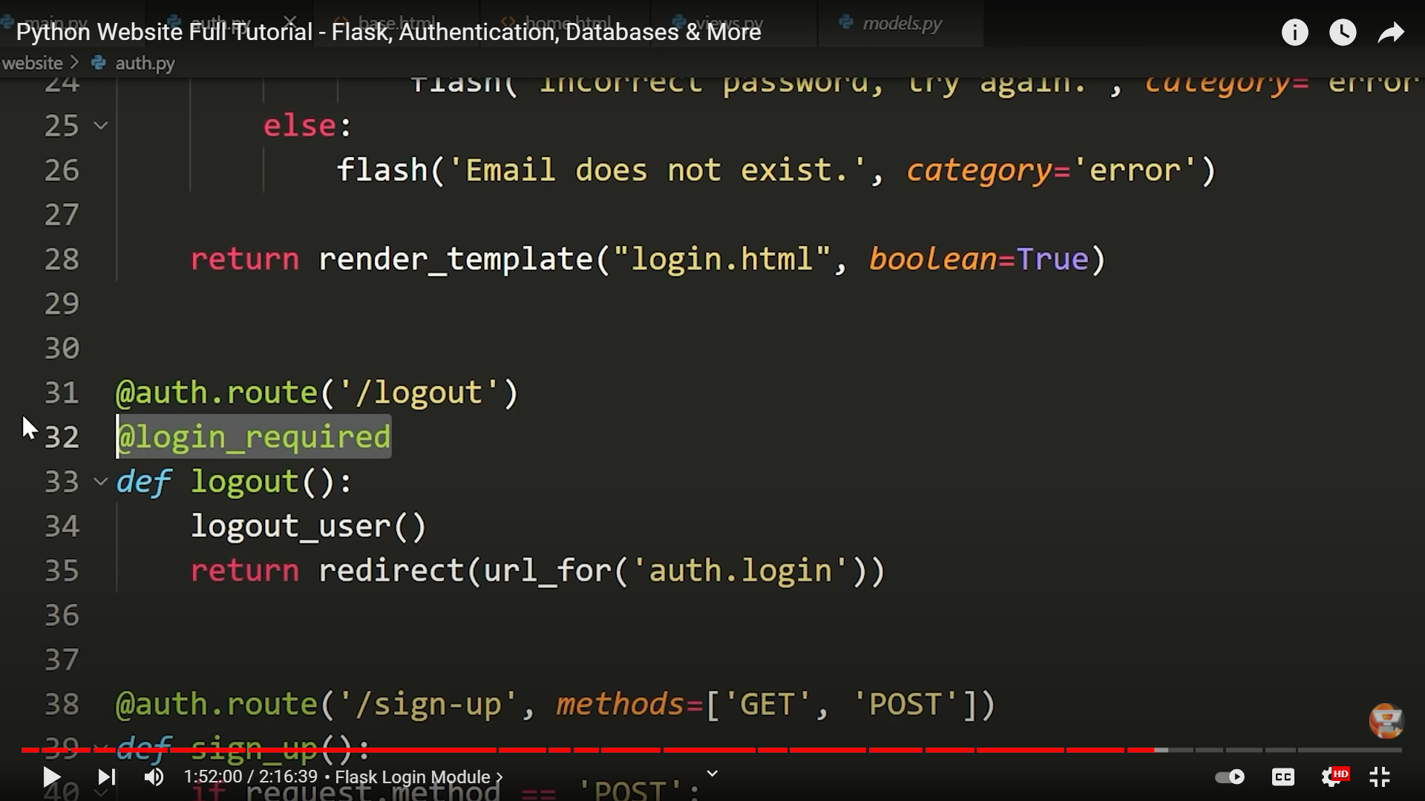

We added another decorator to logout function to make sure the user is logged out if the user is logged in if we don’t add this decorator it ok, but logically adding it makes sense.

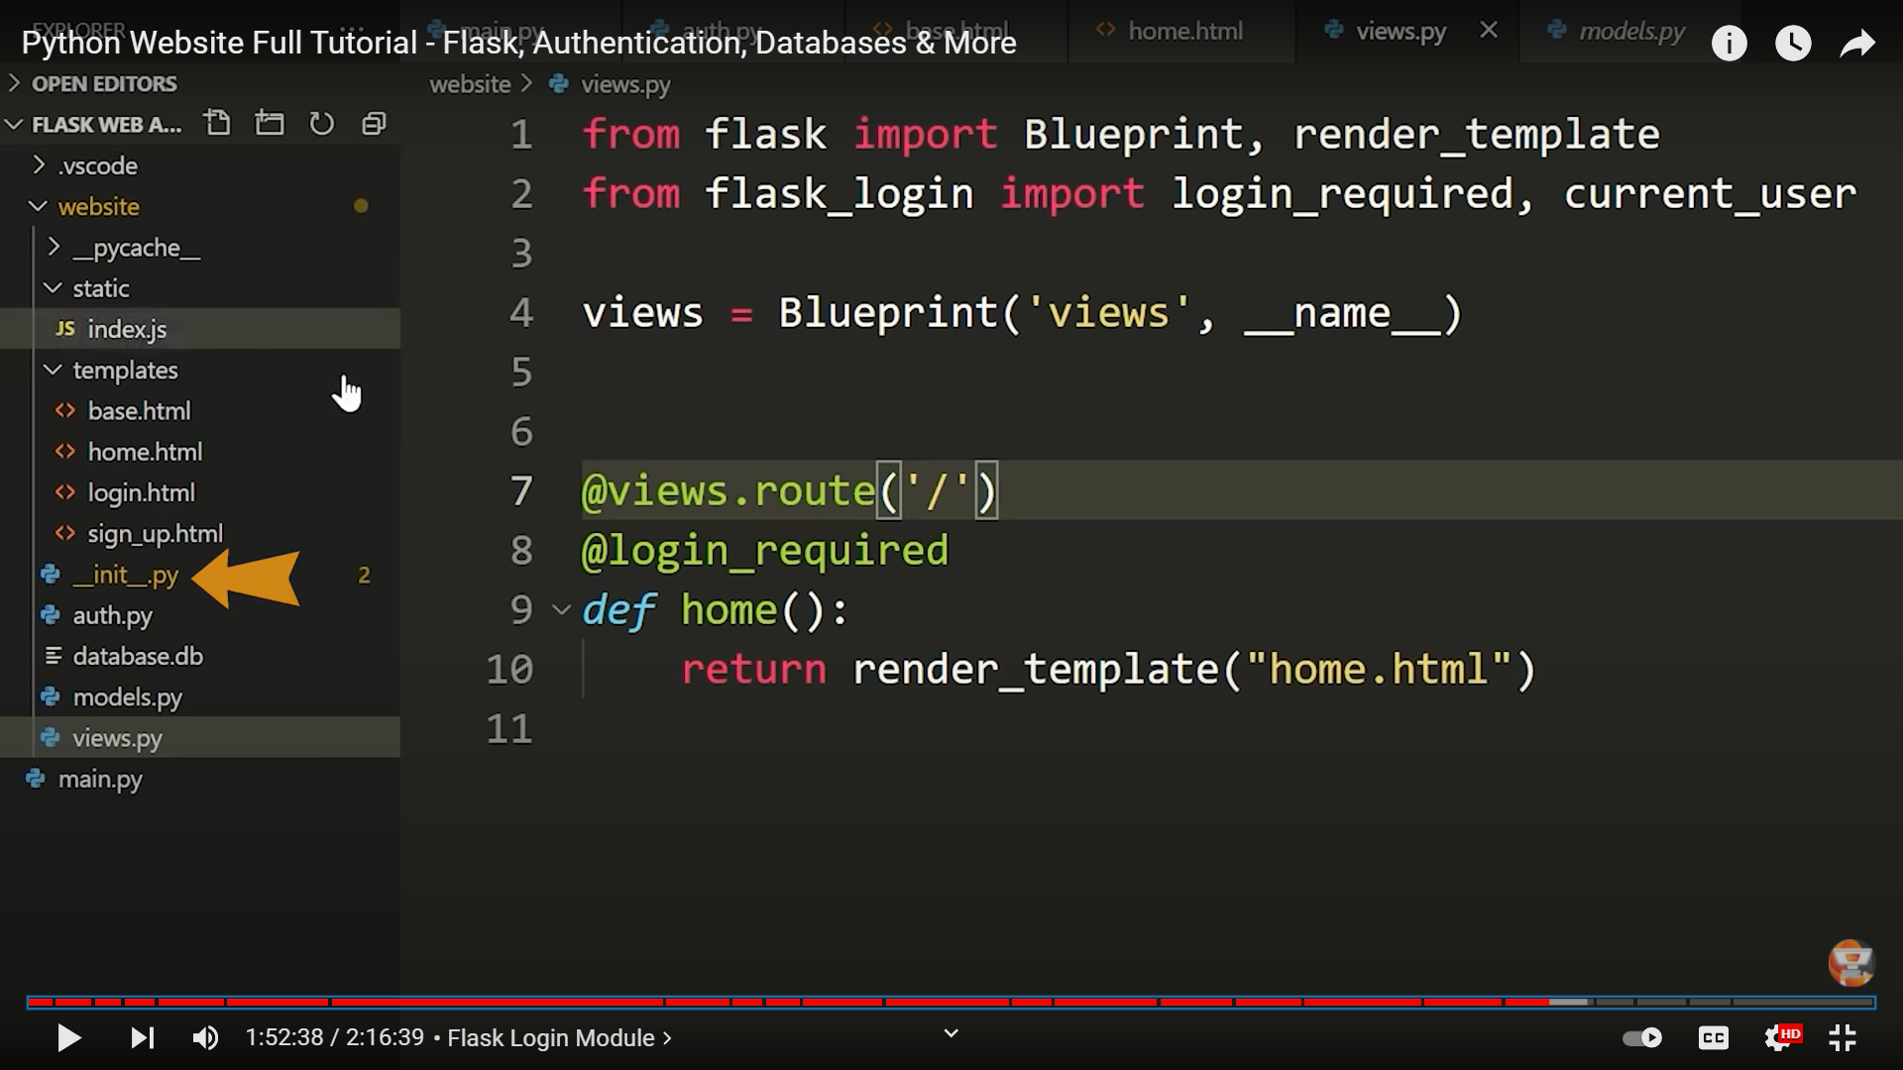

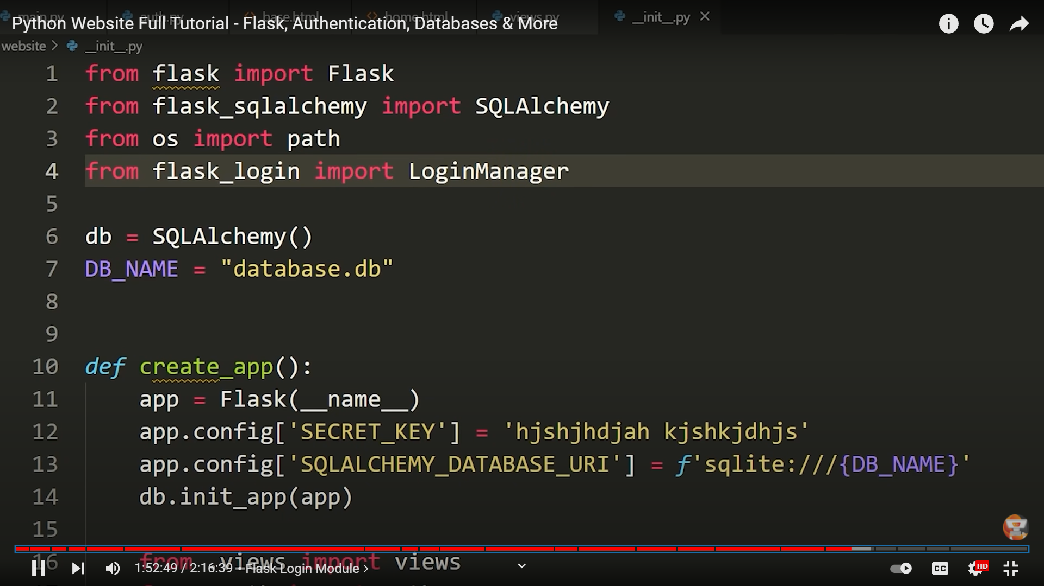

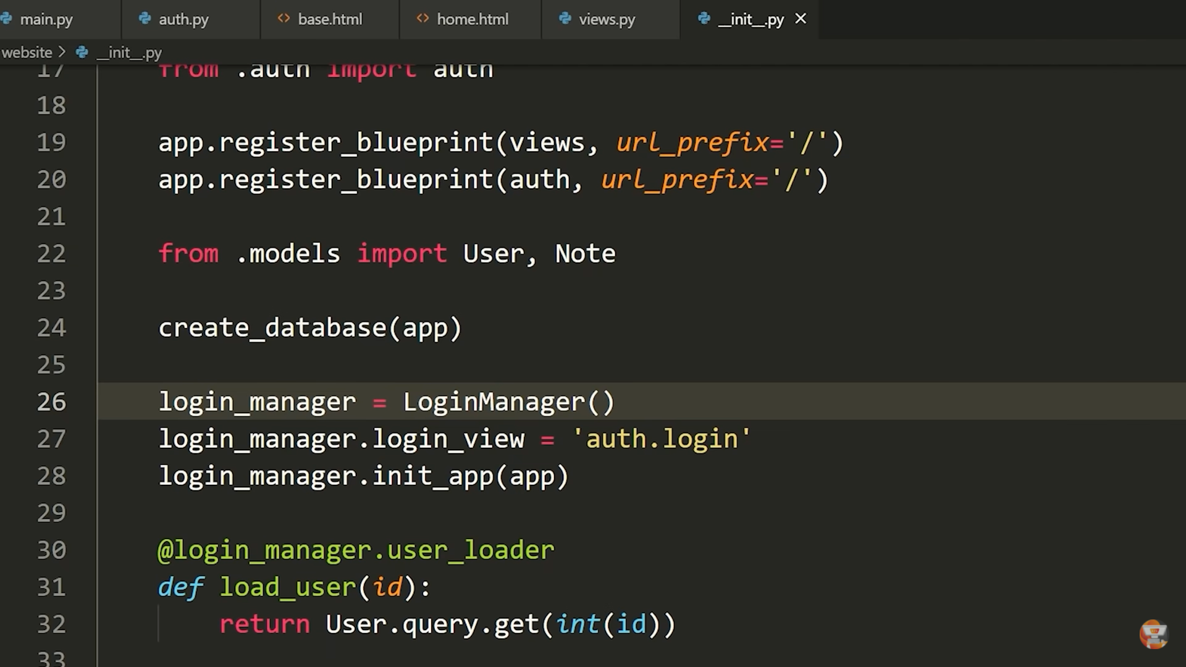

To **manage** the **login** related things we need to use the **login manager** from flask.

where do we go if we are not logged in

for that login_manager.login_view = 'auth.login

telling the login_manager which app we are using by login_manager.init_app(app)

User.**query.get** this works similar to User.query.filter_by except **bydefault** it is going to look for the **primary key**

No need to specify as id=int(id) when we use query.**get** it knows that it looks for the primary key and check if its equal to whatever we pass.

We telling flask what user we’re looking for , we are looking for user model and we’re going to reference some by their id.

**@login_manager.user_loader** this is saying use the function to load the user.

Checking if user is logged in

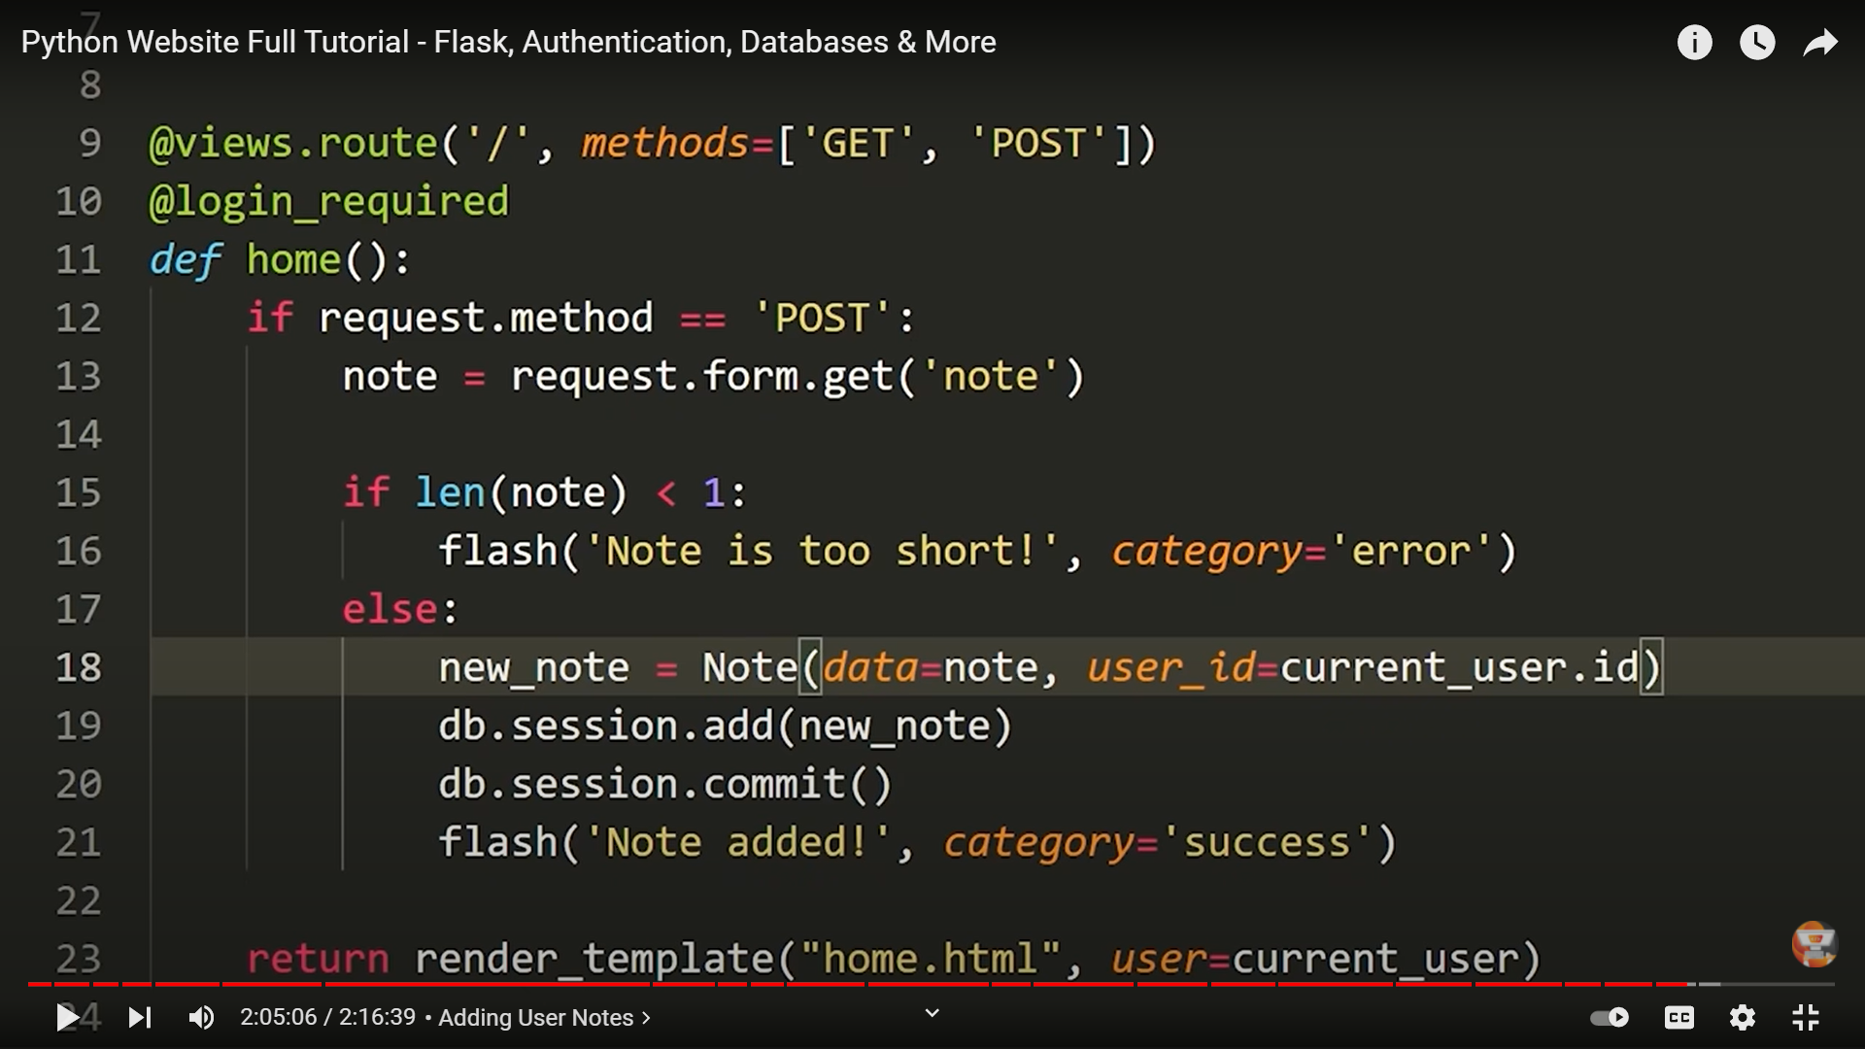

Saving the notes entered by the user

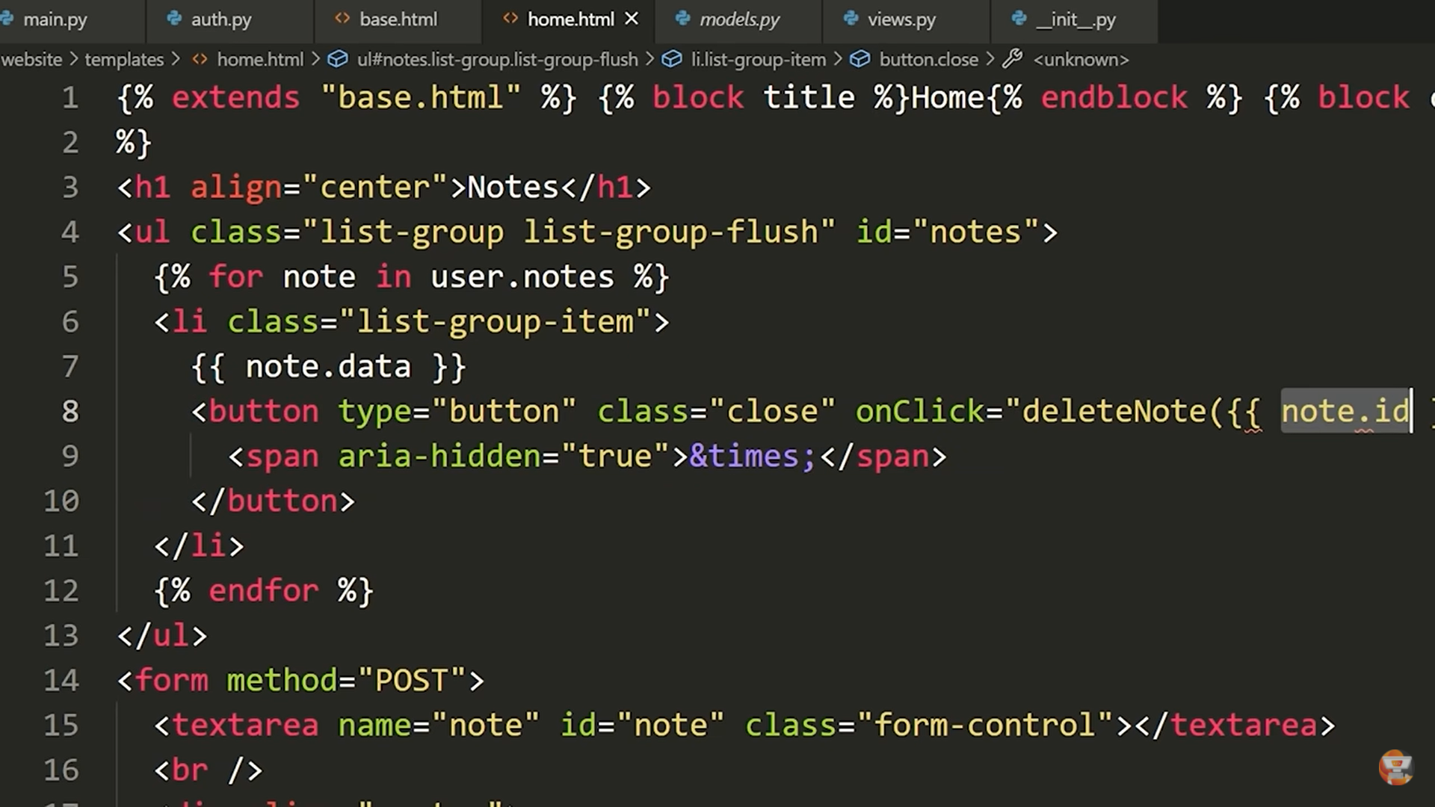

Adding javascript method named deleteNote to delete a note from the database.

The function definition for this deleteNote is written in static folder in index.js file.

Sendrequest in javascript we use fetch()

Window.location.href = ‘/’ (reloading the window)

When we use **get** method it accesses the **primary key**.

Note.query.get(noteId) 🡪 looks Note class whether that has the noteId we are passing